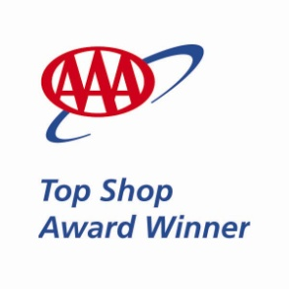

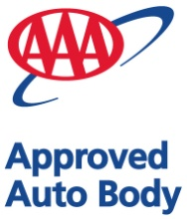

***Reliable Auto Body Receives 2013 AAA Top Shop Award***

Reliable Auto Body in Whitehall has earned the 2013 AAA Top Shop award for its outstanding performance.

In order for auto collision centers to be considered for AAA’s Top Shop Award, they must meet high standards to be eligible to participate in the AAA Approved Auto Body® program and maintain a consistently excellent customer satisfaction rating throughout the year. Customer satisfaction is measured by input from evaluation cards. The scores for the competing facilities are tallied to determine who will receive the award. The facilities must have an average 97% or higher customer satisfaction score during the rating period in order to qualify for the award.

The AAA Auto Repair Network is AAA’s way of helping millions of motorists find reliable repair service. Facilities that meet or exceed the program requirements must maintain demanding standards for both technical competence and customer service in order to qualify for the Approved Auto Repair and Approved Auto Body programs. The Top Shop award honors those facilities that rank the highest in this elite group based on customer satisfaction and their ability to exceed program standards in areas such as equipment, technician certification, and shop cleanliness.

Reliable Auto Body receives the 2013 Top Shop Leader award, the highest achievement, among AAA-approved auto collision centers in eastern Pennsylvania and southern New York striving for the Top Shop honor.

For more information about the AAA Approved Auto Body® program, visit www.AAA*.*com

***********