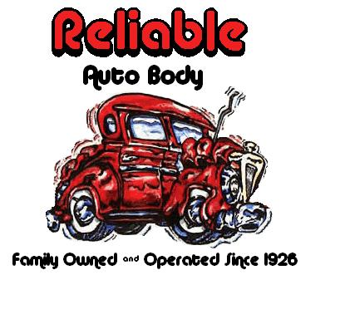

RELIABLE AUTO BODY
967 Sumner Ave.
Whitehall, PA 18052
610-433-6900 fax
www.reliableautobody.com

Many people are unaware of their insurance coverage until it’s too late. Below we have explained some of the most misunderstood areas of an automobile insurance policy, along with our recommendations.

Let us start with your collision coverage, which is the part of your automobile insurance coverage that covers any damage you cause to your vehicle. This is usually the most expensive part of your insurance coverage, and is partly based on the value of your vehicle and your choice of deductible (the lower the deductible the higher the premium). We recommend that the deductible you choose ($0.00-$1000.00) should be what you can financially afford in the event of an accident. Most commonly chosen is a $500.00 deductible. Policyholders should also be aware that hit-and- run accidents are covered under your collision coverage and your collision deductible applies. Collision coverage is an optional coverage on any insurance policy and is not legally required under “state minimums” coverage; however, is required if the vehicle is financed/leased.

Next we have comprehensive coverage, which is the part of your insurance coverage that covers “acts of god” damage to your vehicle. Some examples of this type of damage include, hail, animal hits, vandalism, theft, fire, and flying objects. The deductible carried for this portion of your insurance policy is rather inexpensive in comparison to your collision coverage. Your premium will fluctuate minimally based on the deductible chosen for your comprehensive coverage. We strongly recommend no more than a $100.00 deductible for comprehensive coverage. Once again comprehensive coverage is not legally required on any vehicle except for a financed/leased vehicle.

Some other areas of interest include rental car coverage, which we highly recommend EVERYONE add to their insurance policy. Rental car coverage is very inexpensive (typically under $30.00 a year) and is frequently missed.

We would like to touch on two more areas of interest, the first being “No-Fault” coverage (First-Party -medical benefits) which covers any bodily injuries to yourself as a result of an accident. No-Fault coverage has nothing to do with who was at fault in the accident or the damage to your vehicle. The state minimum coverage is $5,000.00, which we all know is not a lot of coverage if you are taken to the hospital. Finally there is the tort option; full-tort versus limited tort. The full-tort option is more expensive, but allows you to sue in the event of an injury resulting from an accident. The limited tort option is automatically applied unless the full-tort option is specifically requested.

In conclusion a good insurance agent will take the time to make sure you fully understand these options, however, if they do not your friends at Reliable Auto Body will.

